|  |  |  |
| --- | --- | --- |
|  |  |  |
|  |  |  |

**This is Ms. Susan from the Shorewood Public Library. Have you ever heard of the itsy-bitsy spider? Well this week we will be creating a super, silly spider. If we think of spiders as super helpful to the ecosystem and medical research, we can see them in a whole new web of life. The venom of some spiders is used to heal wounds. The silk from the web is even being researched for use as bandages. Spider web silk is actually stronger than steel. Scary or silly, spiders are very amazing creatures.**

1-**Cut a large circle out of cardboard or use paper plate. Cut out a circle in the center, leaving a ring of about 2 inches wide all around. Color or paint the circle. Black or purple are good seasonal colors. Punch holes all around the center ring about ½ inch from the edge. You can make your circle more web-shaped too. For the younger artists, cut slits around the outer edge of the cardboard. Another option is to cover the cardboard web base with pieces of tissue or newspaper and then add the holes when it dries. Use a mixture of glue and water as the adhesive. Glow in the dark or glitter glue looks good when it is dry. Take a piece of yarn or string and weave it back and forth from opposite holes until it looks like a web. Or wrap the yarn around the whole base passing back and forth from opposite slits**

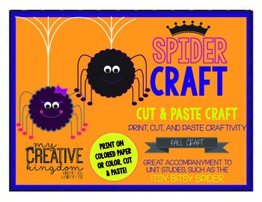**2-Cut a piece of pipe cleaner or a stick into four pieces. Tie a string around all four in the middle. Bend the pipe cleaner to look like spider legs. Wrap another piece of yarn or string around and around the middle many times until it is big, and round like the spider’s body. Glue the end down. Add the spider to the web and tie a string at the top. Hang the silly spider up in the window and catch all those friends and neighbors in your web of warm gratitude.**

**The silliest spiders are the happiest spiders!**

**Ms. Susan**